**Name: Varsha JJ**

**Roll No: 48**

**Batch: B**

**Date: 30/03/22**

**NETWORKING & SYSTEM ADMINISTRATION LAB**

**Experiment No.: 2**

**Aim**

Familiarization of linux command.

**Procedure**

**26. cut –complement -c 1 filename :** Remove first character.

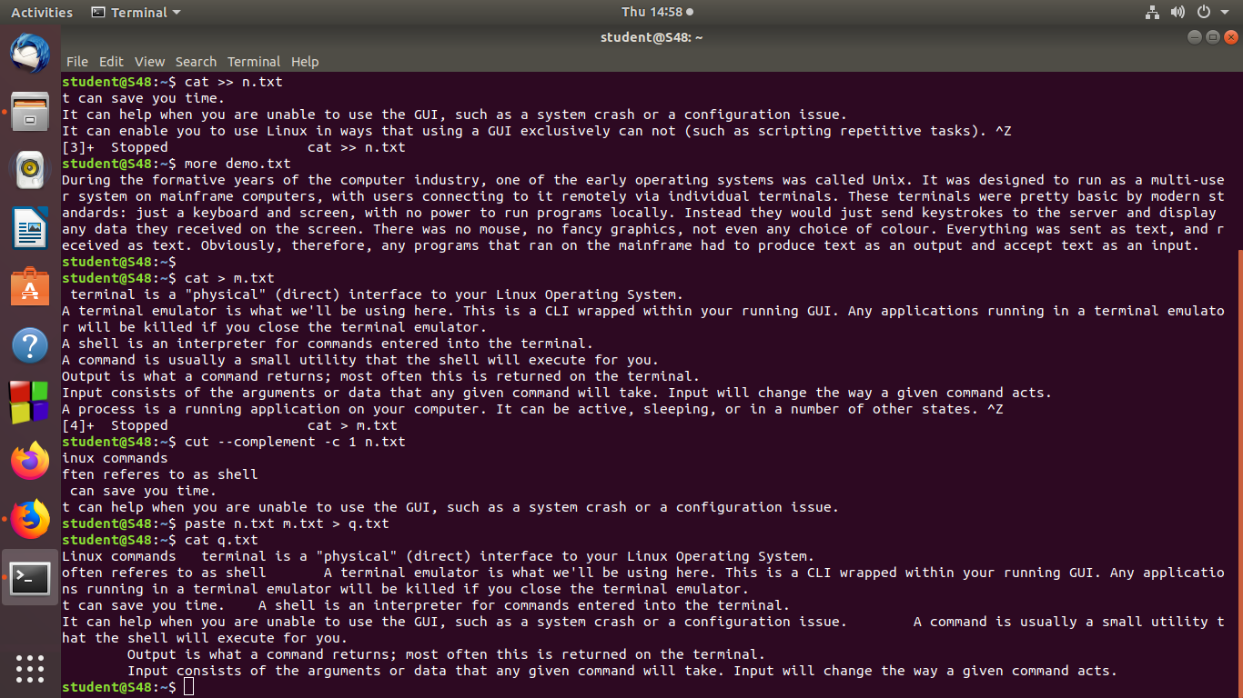

**27. paste file1 file2 :**

**28. paste file1 file2 > file3 :** It is used to join file horizontally by outputting lines consisting of lines from each files specifies ,separated by tab as delimiter to the standard output.



**29. paste -d ‘-‘ filename :**

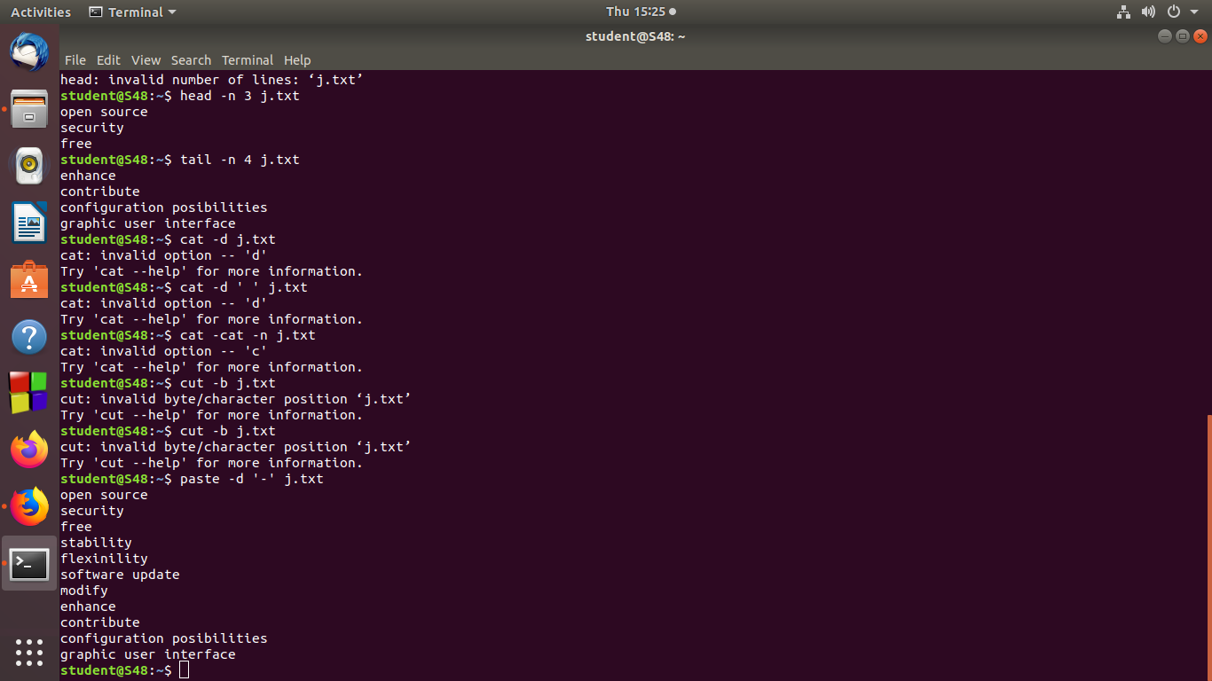

**30. paste –s file1 file2 :**To merge the files in sequentially manner using the –s option.

**31. paste –d ‘%d|’ :** First and second file is separated by ‘%’ and second and third is separated by ‘|’ after that list is exhausted and reduced.

**31. more filename :** It is used to view the text files in the command prompt,displaying one screen at a time in case the file is large.

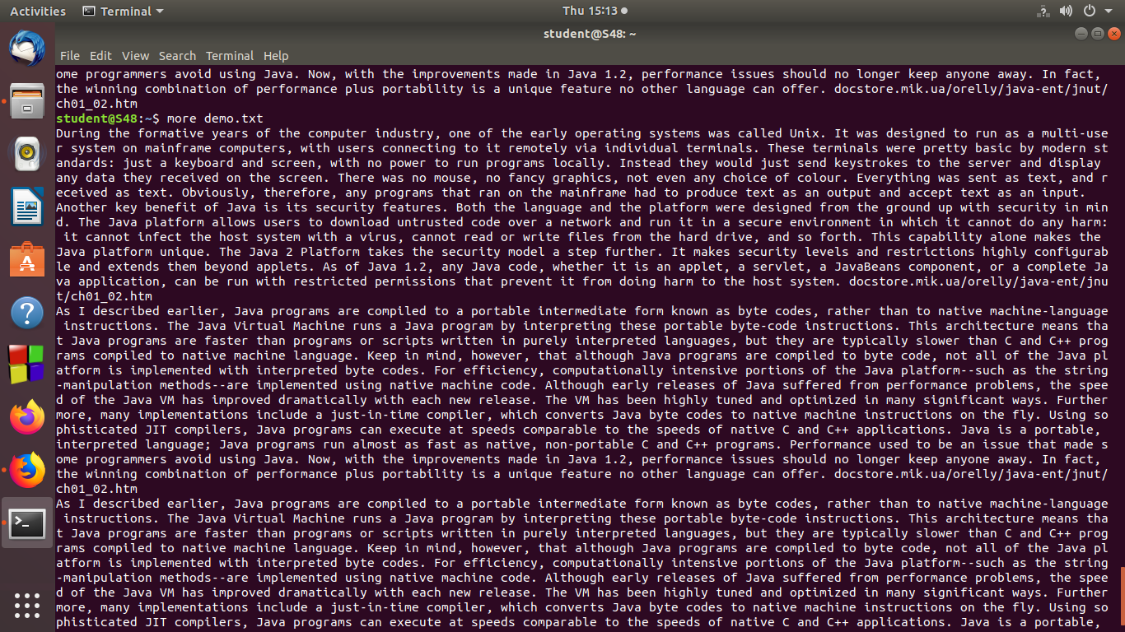

**32.more –s filename :**

**Output Screenshot**